|  |  |
| --- | --- |
|  | BUSTAN QARAAQA annual report 2012 |
|  |  |
| 4/1/2013 | Promoting and implementing Sustainable design in Palestine |

# PRACTICAL INFORMATION

Name of Organisation: Bustan Qaraaqa  
  
Date founded: April 2008  
  
Physical Address: Wadi Hanna Sa’ad, BeitSahour, Bethlehem, West  
Bank,Palestinian Territories  
  
Postal Address: P.O. Box 31316, Jerusalem 91002, Israel  
  
UK Headquarters Address: The Old School, Lydfords Lane, Gillingham, Dorset, UK  
  
Website: [www.bustanqaraaqa.weebly.com](http://www.bustanqaraaqa.weebly.com" \t "_blank)  
  
Email: [bustanqaraaqa@gmail.com](mailto:bustanqaraaqa@gmail.com)  
  
Phone: [+972 2 274 8994](tel:%2B972%202%20274%208994)  
  
Registration: Branch of the Permaculture Association (UK), Charity no. 1116699  
  
Bank details: Bustan Qaraaqa, Lloyds TSB, Gillingham, Dorset, Account  
no: 0052001, Sort-code: 30-93-45

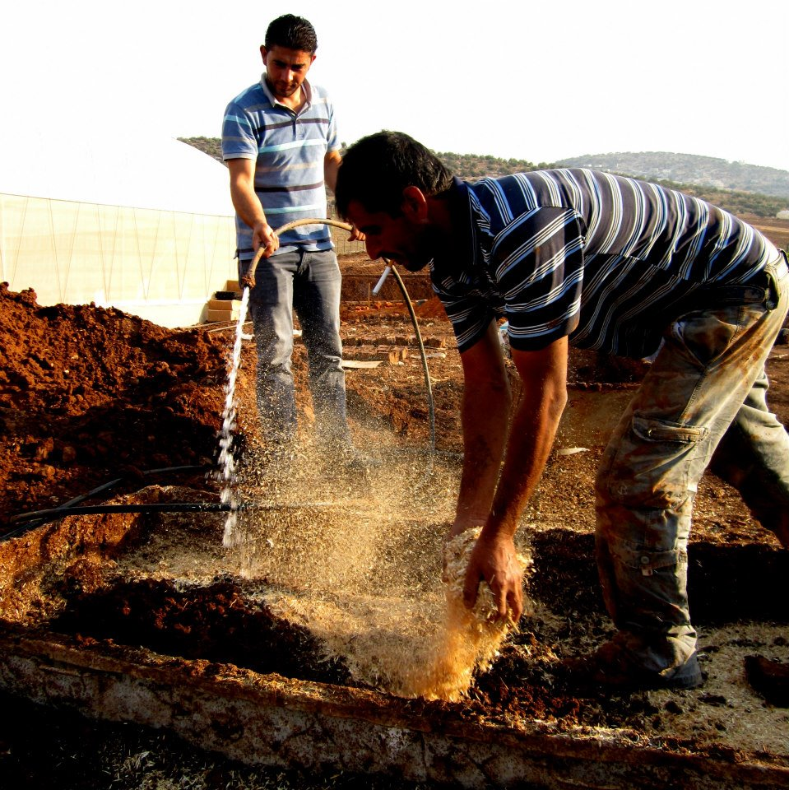

PROJECT DESCRIPTION

Bustan Qaraaqa is a five year old project that introduces, promotes, implements and provides education and training on sustainable, cheap, alternative and long-term solutions for different local communities in the West Bank area, with special emphasis on water and food security. We use the methods of permaculture that can be defined as:

"Consciously designed landscapes which mimic the patterns and relationships found in nature, while yielding an abundance of food, fibre and energy for the provision of local needs." David Holmgren

Bustan Qaraaqa has a small staff and thus is dependent on seasonal international volunteers and local Palestinians to run the farm and help out with the community projects. Since the start in 2008 Bustan Qaraaqa has rented a farm located in Beit Sahour for experimenting and testing out different solutions and designs that later are implemented in our community projects. This is where the volunteers and staff live, where we do environmental training and education, and where we receive thousands of visitors and guests each year. We use minimum expenses on administration and no one except one member of the staff is paid. We have five years experience in the areas of the West Bank and have worked with a wide range of peoples including the Bedouin, refugees, farmers and city-families.

WHAT BUSTAN QARAAQA DO:

* Run environmental education and training for Palestinians and internationals on the farm and in our community projects;
* Create a larger permaculture society in Palestine;
* Promote sustainable, long-term and low-cost design solutions for improving the food and water security in the West Bank
* Design and introduce alternative creative methods and solutions
* Implement sustainable design in local communities in the West Bank
* Create awareness about climate change and environmental challenges among Palestinians
* Research and experimentation

Besides working directly with our community partners, we use our knowledge and experience to educate Palestinians, as well as our international volunteers about the importance of permaculture and sustainability. We often hold courses on our permaculture farm where we welcome everyone, with or without experience to participate.

The project’s farm is located in the area of Bethlehem, where many of the designs and solutions are tested and implemented. We use the farm as an experiment and research center and we welcome thousands of people every year who want to visit and learn about our work. The farm is also the home for the staff and our many volunteers.

WE WORK WITH:

* Regenerative design
* Rainwater harvesting and rainwater storage
* Water cleansing
* Grey water treatment
* Agroforestry
* Ecological building
* Aquaculture
* Life stock

TARGET GROUPS

1. Palestinians who have already got permaculture qualifications and are seeking to make their careers in environmental and social development
2. Palestinian students who wish to gain qualifications
3. Palestinian development professionals
4. Palestinian farmers
5. Foreign students of permaculture

EXPECTED RESULTS

* To transition towards a self-sustaining funding model where income is generated through educational courses.
* To build the confidence and experience of Palestinian permaculture practitioners to become teachers, spreading our work further into more diverse communities.
* To create a pool of skilled Palestinian permaculture consultants and practitioners, transferring our knowledge and skills into the community more effectively.
* To strengthen our links with the international permaculture community, gaining recognition as a centre of excellence for permaculture research, teaching, and design.

PROJECT STRUCTURE

Bustan Qaraaqa’s main base is on our farm where our staff and volunteers live, and where we experiment and do research for our work. With the help of our volunteers we are able to collect natural building materials, sow and preserve and expand our tree nursery and other plants, and we can provide work labour for our community projects. We see the need of having our farm as a base and as a demonstration site is the best possible way for us to promote and test the work we do. We believe that permaculture can have a deep impact and improve citizens lives, not only for their water and food security, but to empower them and give them confidence and make them less dependent on their occupier, Israel.

Our community project structure and policy is to not undermine peoples own will and wish to implement the designs and solutions we offer. We provide minimum financial support and we demand that families and communities take part in the work process themselves together with us. We are always in direct communication with our local partners and make sure that what we do is in line with what the local community want and need.

We measure our success if families outside our local community partners or neighbours are interested in implementing the designs and solutions we have introduced for their friends and neighbours. If a community themselves wants the designs, it proves that they are accessible, easy to develop and are needed.

Our financial structure is based on our international volunteer contributions and private donors. We have been dependent on one external funder since the project started, but our aim is to be as self sufficient as possible in the future. We see this as an exchange of knowledge and education for sustainable and environmental concerns for both internationals and Palestinians.

PROJECT BACKGROUND

Bustan Qaraaqa was founded in April 2008 by a team of four British environmentalists who came together with similar ideas about supporting the growth of a grassroots environmental movement in the Palestinian Territories to address the severe and ongoing humanitarian and environmental crises. It was the view of the founders that permaculture provides a toolkit for people to directly address the problems that are facing them: empowering individuals and communities to take back control over their relationship with the environment, to access life-sustaining resources, to halt environmental degradation, to build resilience and thus to adapt to the effects of climate change and to resist the ongoing occupation and colonization of their country by Israel. We therefore set out to build an experimental permaculture farm that would also serve as a demonstration and education site, and to grow a network of partners in our local community so that we could share our ideas and support the growth of a grassroots movement. The farm house is also the home for the staff and the many numbers of volunteers that stays on the farm each year.

Bustan Qaraaqa sees the area of the West Bank as especially urgent and important because of the challenges connected to the political situation and the rapid climate change.

# CHALLENGES FACING THE CITIZENS OF THE WEST BANK

Palestinians restricted access to their own water and natural resources mainly caused by the political situation in the West Bank, is an urgent issue that has serious health and economic implications creating major challenges in the dry climate region. The total control Israel have over the majority of the land (Area C) makes the lives of Palestinians even harder when they are being displaced due to the expansion of settlements, reduced or non-existent access their own water resources and are restricted to move freely through the West Bank because of barriers, road blocks and internal checkpoints controlled by the Israeli army.

The water situation is not only a problem related to public health issues, but is a major obstacle for many farmers dependent on water irrigation for their crops and farmland.1 The Jordan Valley area that covers 30 percent of the West Bank is located in *Area C* which Israel has total control over. The Palestinian populations in these areas are surrounded by 34 illegal settlements and are counted to be twice as poor as their neighbours living in other parts of the West Bank. The citizens are mostly small farmers that suffer from increasing settler violence, military demolitions of their homes and military checkpoints. A report conducted by OXFAM in 2012 has stated that the areas of Jordan Valley are in urgent need of attention by the international community concerning the Palestinians living there.[[1]](#footnote-1)

The human overview report on the situation in the Palestinian areas conducted by the UN from 2011 concludes that over 300 000 people in the West Bank are either in high or medium risk of chronic water scarcity. Israel has a total control of all underground and surface water resources in the West Bank, and more then 300 000 Palestinians are not connected to a water network. Israel has made it illegal for the people of Palestine to install, upgrade or protect their already existing water systems such as cisterns and wells without their permission, and this is also the case for all building work. 94 percent of all submitted building applications that include water related items were denied by Israeli authorities between the years of 2000 - 2007. A systematic demolition of already existing water related items are destroyed by the Israeli Civil Administration each year, and UN had at least reported 134 water related demolitions and confiscations in 2011 performed by the army. 60 percent of these demolitions were located in areas allocated to settlements. While Palestinians are denied access and rights to their own water, Israel continue to drill deeper and implement and improve their own cisterns and wells for water use.[[2]](#footnote-2)

On 11th of September 2011 the Israeli army destroyed three of the small village’s, An Nassariya, water wells with bulldozers and destroyed the water access for 350 families. They did not show any demolish order and confiscated pumps, engines, filters and 4000 liters of gasoline. (*p. 51in United Nations, “Fragmented lives. Humanitarian overview 2011 in the Occupied territories, May 2012)*

It has also been stated that the number of structures demolished and people being displaced as a result reached their highest numbers since UN started to collect the data in 2006. The reported settler-related violence towards Palestinians also increased drastically in 2011 when 1 death, 109 injuries and 243 incidents targeting Palestinian property was conducted.

Citizens of the West bank may have to buy their own water back from Israel for up to four times the price as Israeli settlers living in occupied territories. As a direct result of the strict water policy Israel are forcing upon Palestinians, many families have no choice other than to travel long distances to get water, something that can be even more time consuming and difficult because of the barriers, settlements, road blocks and internal checkpoints. It has been concluded that

Only 31 percent of Palestinians in the West Bank (excluding East Jerusalem) are connected to a sewage system, and furthermore they are denied permission to construct and build a functional wastewater treatment system. One of the consequences of this is that there are open flow channels that are a major threat to public health and a serious environment concern.

SITE DEVELOPMENT

The Bustan Qaraaqa demonstration farm is the main base for all the work and research that Bustan Qaraaqa are involved in. The farm and farmland is not only the home for staff and volunteers, but is also where we experiment, test and do research. We have to keep the farm opened all year and this is necessary for the thousands of visitors and guests that visits and want to know more about permaculture. We have in 2012 maintained and expanded our tree nursery and farmland, continued the work on the shower and kitchen facility “Beit Izgat”, collected seeds, developed solar ovens and continue our all-year environmental training with work shops.

THE FARM DISPOSES:

* Own rainwater harvesting, storage and grey water treatment system
* The ecological kitchen and shower facility “Beit Izgat”
* A compost toilet
* Tree nursery that consists of the whole National Collection of Palestinian Tree Species
* Hundreds of different tree and plant species
* Segregated storages for different materials used in ecological building
* Education facilities
* Sleeping facilities for the staff, volunteers and guests

TREE NURSERY

Bustan Qaraaqa’s tree nursery has increased in size and has been developed expanding the different tree species during 2012. With the help of our apprenticeship programs and volunteers we have planted over 4000 trees this year alone and provided trees for our community projects. We also have given away hundreds of trees to families and we wish to expand the tree nursery even further.

In 2012 we were also proud to announce that we are in possession of being one of the few that are in the possession of having the whole National Collection of Palestinian Tree Species on our farm. This was achieved after years of seed collection, seed protection and preservation and experiment and research of planting and sowing. Many organisations and institutions have also showed interest in our tree nursery, and RIWAQ (Centre for Architectural Conservation in Palestine) have taken initiative to cooperate with us in preserving these tree species in the future.

|  |  |  |
| --- | --- | --- |
|  |  |  |

BEIT IZGAT

Beit Izgat is the farms own designed and built ecological kitchen and shower facility. We finished the process of building and installing Beit Izgat in 2012. We used natural building materials where the walls are made out of glass bottles and mud. It also includes our own grey water treatment system that runs from the shower and kitchen throughout the farms land and back again. We use no soap or chemicals in the facility and within a year we have grown large banana trees in the middle of the kitchen, as well as installing a fishpond. Beit Izgat is a handmade project that demonstrates a variety of designs connected to our work in community projects and are used daily by our staff and volunteers.

|  |  |  |
| --- | --- | --- |
|  |  |  |

SOLAR ENERGY

Bustan Qaraaqa uses solar energy to produce hot water and also for cooking. In 2012 together with a local craftsman, we developed and designed a solar oven that was implemented with great success in different communities. We made several prototypes and a developed a final design that we are happy and proud to present to people. It is easy to use by exploiting the power of the sun to heat up everything from coffee to food, it is large enough to contain several pots at a time and can easily be situated on a balcony or in the garden.

|  |  |  |
| --- | --- | --- |
|  |  |  |

VOLUNTEER PROGRAM

Bustan Qaraaqa has ran an all year volunteer-program since the project first started. The volunteers come from all over the world and live on the farm in Beit Sahour. The volunteers are the main work force to maintain the tree nursery and other farm related activities. They are also involved in the community projects and their financial contributions are the main source of income to keep the project running.

VOLUNTEER REPORT 2012

In 2012 Bustan Qaraaqa had 55 volunteers that stayed and worked on the farm, higher than the number we measured from the last report. 12 out of 55 stayed on the farm for one week, 12 stayed for 2-3 weeks, and 8 stayed for one month or more. The number of long-term volunteers has in 2012 increased and we see this as a positive sign and prove that our volunteer-program is working well. This also emphasized the importance of having a full-time volunteer coordinator to run the program to help them feel safe and taken care of. Our apprentice that was hired this year has had this as a part of his environmental training and we want to expand the number of Palestinian involvement in the future by offering another apprenticeship.

The total income from having volunteers and their contribution in 2012 was 44 330 ILS, that is 55 percent of Bustan Qaraaqas income in 2012. The money from the volunteer contributions in 2012 has been used for educating and training of the volunteer coordinator, food, service bills and other farm expenses.

COMMUNITY PROJECTS 2012

In 2012 Bustan Qaraaqa have been involved with three community permaculture farms situated in the areas of Jordan Valley, and a permaculture demonstration and education centre located in Jenin. All the projects have been in collaboration with the Palestinian organisation, Ma’an Development Agency.

# Fostering Adaptation to Climate Change among Farming Systems in the Northern Jordan Valley

The areas of Jordan Valley are located mainly in area C of the West Bank over which Israel has total control, and were found by the UN to be the most difficult areas for Palestinians to move across and to access water, and where the people are twice as poor as Palestinians living in other areas in the West Bank.

The project in the Jordan Valley has a goal to raise awareness among farmers in the northern Jordan Valley (area C) about climate change threats as well as to enhance their capacity to promote and adopt eco-friendly agro-land techniques that will assist them in building resilience and in lessening their vulnerability to climatic risks. Bustan Qaraaqa has consulted and designed the projects that are located in communities in Bardelah, Al-Farasiyeh and Tel-il-Hammah.

Bardelah permaculture community farm

Al-Farasiyeh permaculture community farm

At the mouth of a rocky wadi of saline springs on the baking floor of the Jordan Valley, Al Farasiyeh Community farms to survive in harsh conditions under military restrictions. Here we will implement rainwater harvesting and diverse sustainable agroforestry, including unusual and valuable crops, to protect the soil and maximise the potential productivity of the land.

Tel-il-Hammah community permaculture farm

With the community of Tel Hammah in the North Jordan Valley, Palestine, we work with the Bedouin community by pioneering the use of saline spring water for an intensive silvopastural-aquaculture system sustainably producing beef, dairy, honey, fish, prawns, fodder, fruit, nuts , veg and fuelwood.

# Beit Qad permaculture demonstration site

Bustan Qaraaqa has worked as an external design consultant for the development, design and building of the permaculture demonstration site in Beit Qad North in Palestine. This demonstration site is built on one of Palestine’s most fertile lands and will work as an education and visitor center to promote sustainable design.

BUDGET 2012

|  |  |  |  |
| --- | --- | --- | --- |
| EXPENCES | **Monthly** | **YEARLY** | **Comment** |
| **Rent** | 3000 | 36 000 | Monthly rent for the farm and farm land |
| **Apprenticeship** | 2000 | 26 000 | Full-time volunteer coordinator and trainee |
| **Food & TRANSPORT** | 1301 | 16 185 |  |
| **Farm expences** |  | 3408 |  |
| **Electricity** | 95 (aprox) | 1140 |  |
| **Telephone** | 300 (aprox) | 3600 |  |
| **Internet** | 67 | 804 |  |
|  |  |  |  |
|  |  | **87 137 ILS** |  |

Bustan Qaraaqa was able in 2012 to collect the majority of the income from the financial contribution of the volunteers and some previous volunteers private donation. We see this as a positive sign that we are over 50 percent self sufficient and we wish to increase our own income. 45 percent of the income was funded by SLUSH who contributed by paying the monthly rent that covers the majority of Bustan Qaraaqas budget. We have in 2012 decided to invest in environmental training and by that taken in one apprenticeship that has volunteered on the farm for many years. He is a 21 year old man from Beit Sahour and has also worked as a volunteer-coordinator that the project in dependent on to maintain the volunteer program.

|  |  |  |  |
| --- | --- | --- | --- |
| CONTRIBUTION | **Monthly** | **2012** | **Comment** |
| **Volunteer contribution** | 3710 | 44 530 | 55 volunteer in 12 months. |
| **LUSH & SLUSH fond** |  | 36 000 | Funded our rent |
| **Total income** |  | 80 530 |  |
| **Total outcome** |  | 87 137 |  |
| **End result** |  | * **6607** |  |

This budget is measured by the fiancés from January 2012-December 2012. The rent of the farm and farm land was by May 2013 raised to 5000 ILS, a raise of about 40 percent.

ACTIVITY 2012 AND FURTHER WORK FOR 2013

Bustan Qaraaqa is an experimental permaculture farm where techniques to address the environmental problems facing the Palestinian people are developed and tested. The farm also serves as an education centre to the volunteer team who help to implement the projects.

Tried and tested techniques are then implemented in the Palestinian community.

1. We are together with Ma’an Development Agency building tree community permaculture farms in the Jordan Valley area in:
   1. Al-Farasiyeh: Here we will implement rainwater harvesting and diverse sustainable agroforestry, including unusual and valuable crops, to protect the soil and maximise the potential productivity of the land.
   2. Tel-Il-Hammah: Here Bustan Qaraaqa work with the Bedouin community of Tel Hammah in the North Jordan Valley, Palestine. Here we are pioneering the use of saline spring water for an intensive silvopastural-aquaculture system sustainably producing beef, dairy, honey, fish, prawns, fodder, fruit, nuts , veg and fuelwood.
   3. Bardelah: Here we work with rainwater harvesting and rainwater storage ponds, as well as implementing a grey-water system. We will continue to work with natural building materials as mudbricks, while also focusing on agroforestry and planting of herbs to stimulate the growth of other species.
2. We are together with Ma’an Development Agency building a permaculture farm and education centre in Beit Qad. The site will demonstrate rainwater harvesting, sustainable agroforestry, high value crops, fish farming, aquaponics and ecobuilding on a comercial scale in the heart of the West Bank's most important agricultural area.
3. In 2012 we hired Odai (20) as an apprenticeship and volunteer-coordinator. Odai have been active at Bustan Qaraaqa since the project started, and we see this as an important investment to further educate him, and as needed step towards handing the project into Palestinian hands in the future. We have strong ambitions of being able to take in another apprenticeship in 2013 if we are financially capable of providing salary for him/her.
4. Earlier this year we held a Permaculture Design Certificate course at the farm where the majority was Palestinians. About 40 students from Hebron University joined in one session, and we have strong ambitions of holding two more courses by 2013 and 2014, one in English and one in Arabic.
5. Designing and building a permaculture system at our farm including rainwater harvesting, agricultural diversification, and a food forest to provide services and products to the community. The project promotes useful native species, and labour is provided by Bustan Qaraaqa volunteers in partnership with community members. Trees for the system were provided from our on-site nursery (currently the only nursery dedicated to the propagation and promotion of native species in Palestine). In 2012 we completed the total collection of Native Palestinian Tree Species in our tree nursery, after years of research and by collection seeds from various places inside and outside the West Bank.
6. Maintain and develop our innovative eco-greenhouse at Bustan Qaraaqa (‘Beit Igzaz’) built up by glass bottles and mud, the greenhouse are demonstrating water harvesting and grey-water recycling, passive heating and cooling, solar ovens etc.
7. Domestic-scale fish farming for food at the Bustan Qaraaqa farm, combining rainwater harvesting, green-water aquaculture, and silviculture, to directly integrate solutions to food and water insecurity. We run and hope to continue running weekly workshops on these techniques and demonstrate them at our core site.
8. Bustan Qarraqa will, by the summer of 2013 with support from The Commission's European Community Humanitarian Office (ECHO) and Danish Church Aid, start the research project "Regenerative methodology for sanitary drinking water from rural system"

# AMBITIONS AND GOALS

* Build up steady members of staff
* Host a Permaculture Design Certificate course in Arabic
* Improve our volunteer program
* Involvement with more community partners
* Expand and further develop our tree nursery
* Maintain our farmland and Beit Izgat
* Develop and improve our solar oven industry
* Take in one more Palestinian apprenticeship
* Hold more permaculture work shops

REFERENCES

Samuel Martin

Global Funding Officer Dan Church Aid   
Mobile: 970 (0) 598 944 413  
[ssm.palestine@dca.dk](mailto:ssm.palestine@dca.dk" \t "_blank)

Maria Fuensanta Hernandez Gil

Ma’an Development Center , Rammalah Office

[maria@maan-ctrl.org](mailto:maria@maan-ctrl.org)

Dr.Mazin Qumsiyeh

Professor at Bethlehem University

mazin@qumsiyeh.org

BUSTAN QARAAQA annual report 2012

Promoting and implementing Sustainable design in Palestine

1. *OXFAM “On the brink, Israeli settlements impact on Palestinians living in Jordan Valley, 2012* [↑](#footnote-ref-1)
2. *United Nations, “Fragmented lives. Humanitarian overview 2011 in the Occupied territories, 2012* [↑](#footnote-ref-2)